Smart City Traffic Management System
Dynamic Density-Based Traffic Light Controller
Software-Based Simulation using Python and Google Colab
1. Aim
To simulate a Smart City Traffic Management System that dynamically controls traffic lights based on vehicle density in four road lanes, thereby giving the green signal to the busiest lane and reducing the number of waiting vehicles.
2. Objectives
• To model traffic flow in North, South, East, and West lanes using software.
• To generate random vehicle arrivals for each lane.
• To identify the lane with the highest traffic density.
• To dynamically assign the green signal to the busiest lane.
• To simulate the clearing of vehicles during every traffic cycle.
• To visualize the traffic queue and demonstrate dynamic traffic control.
3. Software Required
Software / Library | Purpose | Environment
Google Colab | Cloud-based execution of Python code | Web browser
Python 3 | Traffic simulation and control logic | Google Colab
Random | Generation of vehicle arrivals and clearing capacity | Python library
Matplotlib | Traffic data visualization | Python library
IPython.display | Clearing previous cycle output | Google Colab
Time | Delay between simulation cycles | Python standard library

4. Problem Statement
Conventional fixed-time traffic lights may allocate the same green-light duration to all roads even when traffic density is different. This can increase vehicle waiting time and congestion. The proposed software simulation uses a density-based approach in which the lane containing the largest queue is selected for the green signal. Vehicles are then cleared from that lane before the next cycle.
5. System Overview
The Smart City Traffic Management System represents four connected traffic lanes: North, South, East, and West. Each lane maintains a queue of waiting vehicles. During every simulation cycle, new vehicles arrive randomly. The controller compares the four queue sizes, identifies the busiest lane, assigns a green signal to that lane, and removes a randomly selected number of vehicles. The remaining queues are displayed graphically.
6. System Architecture
Layer | Component | Function
Traffic Input | Vehicle Arrival Generator | Generates new cars for each lane
Data Layer | Lane Queues | Stores the number of waiting vehicles
Decision Layer | Density Controller | Finds the lane with maximum queue
Control Layer | Traffic Light | Sets selected lane to GREEN
Output Layer | Matplotlib Graph | Displays queue sizes and traffic status

7. Methodology
• Four traffic lanes are initialized with different vehicle queues.
• At the beginning of every cycle, random vehicles are added to each lane.
• The controller calculates the maximum queue using the index of the largest value.
• The corresponding lane is selected as the active lane.
• The active lane receives a green signal while the other lanes remain red.
• A random number of vehicles between 4 and 8 is selected for clearing.
• The number of cleared vehicles cannot exceed the number of vehicles waiting in the active lane.
• The updated queue values are plotted for visual monitoring.
• The process continues for 20 traffic cycles.
8. Procedure
1. Initialize lane names as North, South, East, and West.
2. Initialize queues as [5, 2, 8, 3].
3. Set simulation_steps = 20.
4. For every cycle, generate four random arrival values from 0 to 5.
5. Add arrivals to the corresponding queues.
6. Find the lane having the maximum queue.
7. Set that lane as the active green-light lane.
8. Generate a random clearing capacity from 4 to 8.
9. Clear the smaller of the queue size and clearing capacity.
10. Plot the current queue sizes using green for the active lane and red for other lanes.
11. Wait 1.5 seconds and proceed to the next cycle.
12. Stop after 20 cycles.
9. Python Program
# ============================================
# Smart City Traffic Management System
# Dynamic Density-Based Traffic Light Controller
# Google Colab Version
# ============================================

import random
import matplotlib.pyplot as plt
from IPython.display import clear_output
import time

# Lane names
lanes = ["North", "South", "East", "West"]

# Initial queue of cars
queues = [5, 2, 8, 3]

# Number of traffic cycles
simulation_steps = 20

for step in range(1, simulation_steps + 1):

# Random new cars arrive
new_cars = [random.randint(0, 5) for _ in range(4)]
queues = [queues[i] + new_cars[i] for i in range(4)]

# Find busiest lane
active_lane = queues.index(max(queues))
active_lane_name = lanes[active_lane]

# Cars cleared
cars_cleared = min(queues[active_lane], random.randint(4, 8))
queues[active_lane] -= cars_cleared

# Clear previous graph
clear_output(wait=True)

# Colors
colors = ['red', 'red', 'red', 'red']
colors[active_lane] = 'green'

# Plot graph
plt.figure(figsize=(8,5))
plt.bar(lanes, queues, color=colors)

plt.ylim(0,30)
plt.ylabel("Number of Cars Waiting")
plt.xlabel("Traffic Lanes")
plt.title(f"Traffic Cycle {step}: Green Light -> {active_lane_name}")

# Display values on bars
for i, value in enumerate(queues):
plt.text(i, value+0.5, str(value),
ha='center', fontsize=12)

plt.figtext(
0.5,
0.01,
f"Action: Cleared {cars_cleared} cars from {active_lane_name}",
ha='center',
fontsize=12,
bbox=dict(facecolor='white', edgecolor='black')
)

plt.show()

# Wait before next cycle
time.sleep(1.5)

print("Simulation Completed Successfully!")
10. Simulation Output
The program performs 20 traffic cycles. In every cycle, vehicle arrivals are randomly generated, the busiest lane is selected, and vehicles are cleared from that lane. The following graphs summarize one reproducible software run. Since the original program uses random values, individual results may differ when the code is executed again.
Cycle | Green Lane | Cars Cleared | Total Cars Remaining
1 | East | 4 | 25
2 | West | 8 | 23
3 | South | 4 | 24
4 | North | 4 | 27
5 | South | 4 | 34
6 | South | 4 | 45
7 | East | 5 | 51
8 | South | 7 | 51
9 | West | 6 | 54
10 | North | 8 | 56
11 | South | 4 | 64
12 | South | 4 | 73
13 | North | 8 | 78
14 | West | 7 | 83
15 | South | 5 | 84
16 | South | 7 | 87
17 | East | 8 | 91
18 | West | 5 | 93
19 | West | 4 | 98
20 | North | 6 | 105

11. Graphical Results

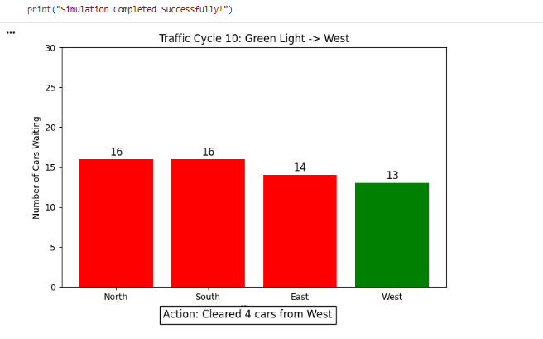
12. Result
The Smart City Traffic Management System was successfully simulated using Python in Google Colab. The dynamic controller continuously monitored the four lane queues, identified the lane with the highest traffic density, assigned the green signal to that lane, and cleared vehicles before moving to the next cycle. The simulation demonstrates the basic principle of density-based adaptive traffic signal control without requiring physical traffic lights or sensors.

